Assignment No 1

Assignment given date: 16th Jan 2017

**Assignment submission date: 30th Jan 2017**

All assignments will be evaluated to **5 marks** in internal evaluation

Q1. Write HTML code for the following tables:

On A4/Assignment sheet and hand written neat and clean with output

1. 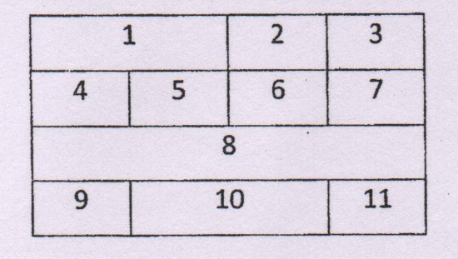
2. 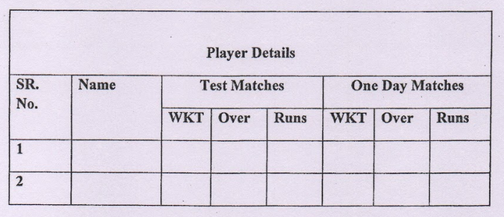
3. 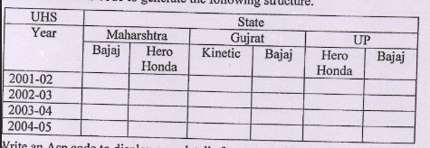

D)